Government Arts and Science College

Srivilliputhur

Unlocking Insights Into the Global Air Transportation

Network with Tableau

1.Introduction

Unlocking insights into the global air transportation network with Tableau is a powerful endeavor that allows us to delve deep into the intricacies of this complex and vital industry. In today's fast-paced and interconnected world, the aviation sector plays a pivotal role in connecting people and goods across the globe. To better understand and optimize this network, we turn to Tableau, a cutting-edge data visualization and analytics tool. This platform empowers us to transform raw data into actionable intelligence, providing a comprehensive view of the global air transportation system.

The global air transportation network is a web of airports, airlines, routes, and passengers, each contributing to the industry's dynamic and ever-evolving landscape. Tableau's intuitive interface, rich visualizations, and data analysis capabilities allow us to unearth critical insights that can shape the future of aviation. From assessing the performance of individual airlines and airports to tracking industry trends, identifying potential bottlenecks, and enhancing safety measures, Tableau is the key to unlocking the potential within the vast sea of data generated by this intricate network.

This journey into understanding the global air transportation network with Tableau offers an opportunity to foster innovation, improve efficiency, and ensure the seamless movement of people and goods worldwide. In this pursuit, we will explore data-driven narratives, uncover hidden patterns, and make informed decisions that can impact not only the aviation industry but also the global economy and the way we experience the world. So, let's embark on this exciting voyage, harnessing the power of Tableau to unlock valuable insights and drive meaningful changes within the realm of air transportation.

1.1.Overview:

1. **Data-Driven Insights**: Tableau enables the transformation of raw data into actionable insights. By harnessing the power of data analytics, we can uncover valuable information that can inform decision-making processes, optimize operations, and enhance safety measures within the aviation industry.
2. **Comprehensive Visualization**: Tableau's intuitive interface and visualization capabilities allow us to create dynamic and interactive dashboards. These dashboards provide a holistic view of the global air transportation network, making it easier to interpret and communicate complex data.
3. **Performance Assessment**: We can use Tableau to assess the performance of individual airlines, airports, and routes. This helps in identifying strengths, weaknesses, and areas for improvement, ultimately leading to better decision-making and resource allocation.
4. **Trend Analysis**: The platform allows for the tracking of industry trends and patterns, which can be crucial for making predictions, understanding market dynamics, and adapting strategies to changing conditions.
5. **Operational Optimization**: By analyzing data related to flight schedules, passenger demand, and route efficiencies, we can optimize various aspects of air transportation operations, leading to cost savings and enhanced customer experiences.
6. **Safety Enhancements**: Tableau can assist in monitoring safety metrics and identifying potential issues or bottlenecks, contributing to the continuous improvement of safety standards in aviation.
7. **Innovation and Growth**: Insights derived from Tableau can foster innovation within the aviation sector. These insights may lead to the development of new technologies and approaches to enhance the network's efficiency, capacity, and sustainability.
8. **Global Impact**: Understanding the global air transportation network is not only vital for the industry but also for the global economy. This knowledge can drive changes that affect how we travel, trade, and connect with the world.

In conclusion, unlocking insights into the global air transportation network with Tableau is an exciting journey that utilizes data analytics and visualization to unravel the complexities of this critical industry. By doing so, we can make informed decisions, drive innovation, and contribute to the efficient and safe movement of people and goods on a global scale.

1.2.Purpose

1. **Data-Driven Decision Making**: The primary purpose is to facilitate data-driven decision-making within the aviation industry. By leveraging Tableau's capabilities, stakeholders can access and analyze vast amounts of data, leading to more informed choices that enhance the efficiency, safety, and overall performance of the air transportation network.
2. **Operational Optimization**: Through the insights gained from Tableau, airlines, airports, and regulatory authorities can optimize their operations. This includes route planning, resource allocation, scheduling, and safety measures, ultimately resulting in cost savings and improved service quality.
3. **Safety and Security**: A critical purpose is to enhance safety and security within the air transportation network. By using Tableau to monitor and analyze safety metrics and incident data, the industry can identify potential issues and implement proactive measures to prevent accidents and incidents.
4. **Performance Assessment**: Tableau's data visualization capabilities allow for the in-depth evaluation of the performance of airlines, airports, and specific routes. This information is essential for identifying areas for improvement and ensuring that the industry remains competitive and efficient.
5. **Industry Trends and Forecasting**: Understanding industry trends is vital for making long-term strategic decisions. Tableau helps in tracking and forecasting these trends, aiding in the adaptation of strategies to changing market dynamics.
6. **Efficient Resource Utilization**: The efficient use of resources, including aircraft, personnel, and airport infrastructure, is crucial to the sustainability of the aviation sector. Tableau insights enable better resource allocation, reducing waste and environmental impact.
7. **Innovation and Growth**: One of the key purposes is to foster innovation within the aviation industry. By identifying opportunities for improvement, Tableau can inspire the development of new technologies and operational approaches, leading to growth and sustainability.
8. **Global Connectivity**: The global air transportation network plays a pivotal role in connecting people, cultures, and economies worldwide. The insights gained from Tableau help maintain and improve this vital connectivity, facilitating trade, tourism, and global cooperation.
9. **Economic Impact**: The aviation industry has a significant economic impact on both local and global scales. By enhancing the industry's performance and efficiency through data-driven insights, Tableau contributes to economic growth and job creation.
10. **Safety Culture**: Improving safety standards and fostering a culture of safety is a fundamental purpose. Insights gained from Tableau can lead to the implementation of best practices and the continuous improvement of safety measures.

In summary, the purpose of unlocking insights into the global air transportation network with Tableau is to drive improvements in efficiency, safety, and overall performance within the aviation industry. It also supports the industry's vital role in connecting people and goods on a global scale and contributes to economic growth and innovation.

2.Problem Statement & Design Thinking

The global air transportation network faces numerous challenges, from operational inefficiencies to safety concerns and environmental impacts. Airlines, airports, and regulatory authorities often struggle to make data-driven decisions and optimize their operations, leading to increased costs and potential safety risks. To address these challenges, we need a comprehensive solution that harnesses data analytics and visualization to enhance performance, safety, and sustainability within the global air transportation network.

**Design Thinking Approach**:

Design thinking is a human-centered problem-solving methodology that can be applied to tackle the challenges in the global air transportation network effectively. Here's how design thinking principles can guide the process:

1. **Empathize**: Understand the needs and pain points of various stakeholders within the aviation industry, including passengers, airline operators, airport authorities, and regulators. Conduct interviews, surveys, and observations to gain insights into their challenges and aspirations.
2. **Define**: Clearly define the problem statement, focusing on specific issues such as operational inefficiencies, safety concerns, and environmental impacts. Use the gathered insights to create a comprehensive picture of the challenges faced by the industry.
3. **Ideate**: Brainstorm creative solutions to address the defined problem. Encourage interdisciplinary collaboration between data scientists, aviation experts, and technology specialists to generate innovative ideas.
4. **Prototype**: Create prototypes and proof-of-concept solutions that leverage Tableau's data visualization and analytics capabilities. Develop interactive dashboards and visualization tools to make complex data more accessible and actionable for stakeholders.
5. **Test**: Pilot the prototypes with select stakeholders to gather feedback and refine the solutions. Ensure that the solutions meet the real needs of the industry and align with their goals, whether it's improving efficiency, safety, or sustainability.
6. **Implement**: Based on the feedback and testing results, implement the finalized solutions on a broader scale. Ensure that the solutions are user-friendly, accessible, and integrated into the daily operations of airlines, airports, and regulatory bodies.
7. **Iterate**: Continuously gather feedback and monitor the impact of the implemented solutions. Make iterative improvements based on changing industry dynamics, emerging trends, and evolving needs.

Design thinking, when applied to the problem of unlocking insights into the global air transportation network with Tableau, fosters a user-centered approach that aims to create data-driven tools and solutions that directly address the challenges faced by the aviation industry. It encourages innovation, collaboration, and adaptability, ensuring that the solutions remain relevant and effective over time.

2.1. Empathy Map:

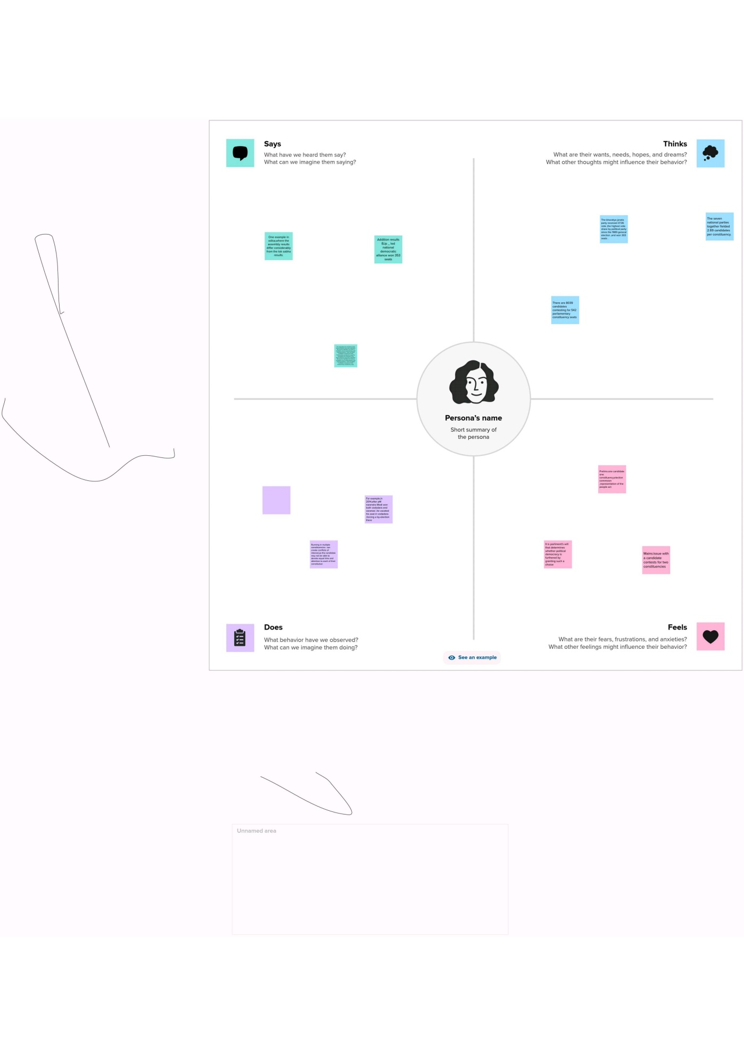

2.2.Ideation and Brainstorming Map:

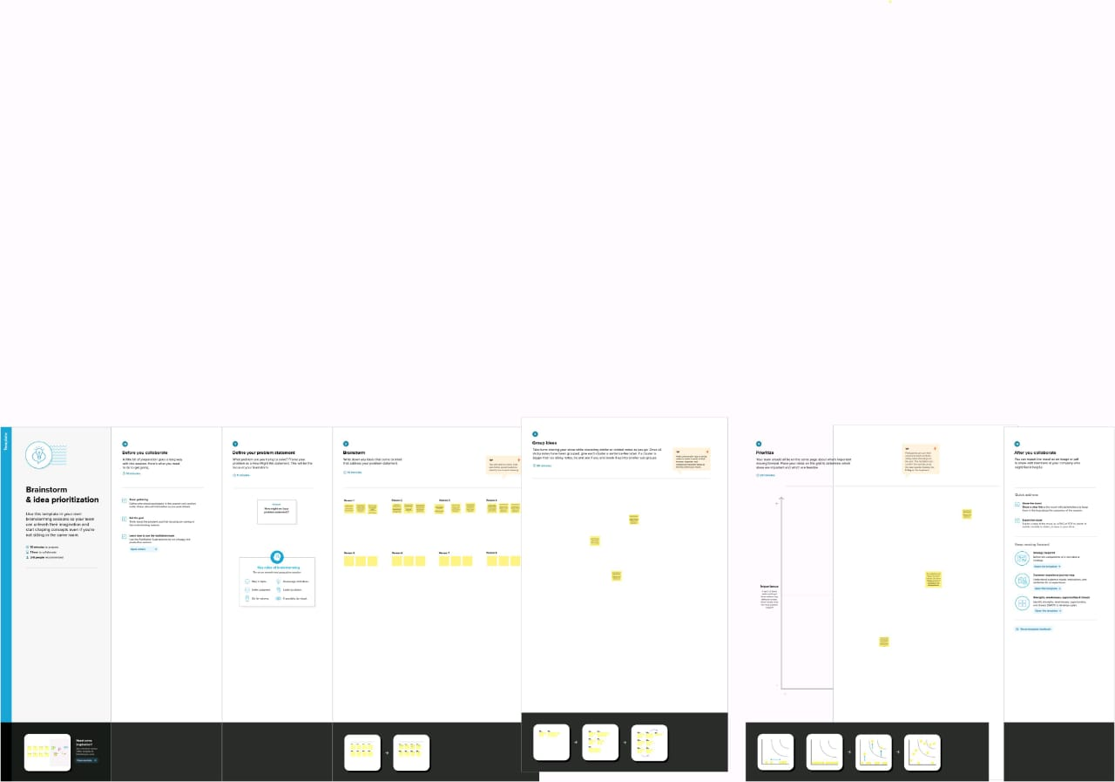

3.Result:

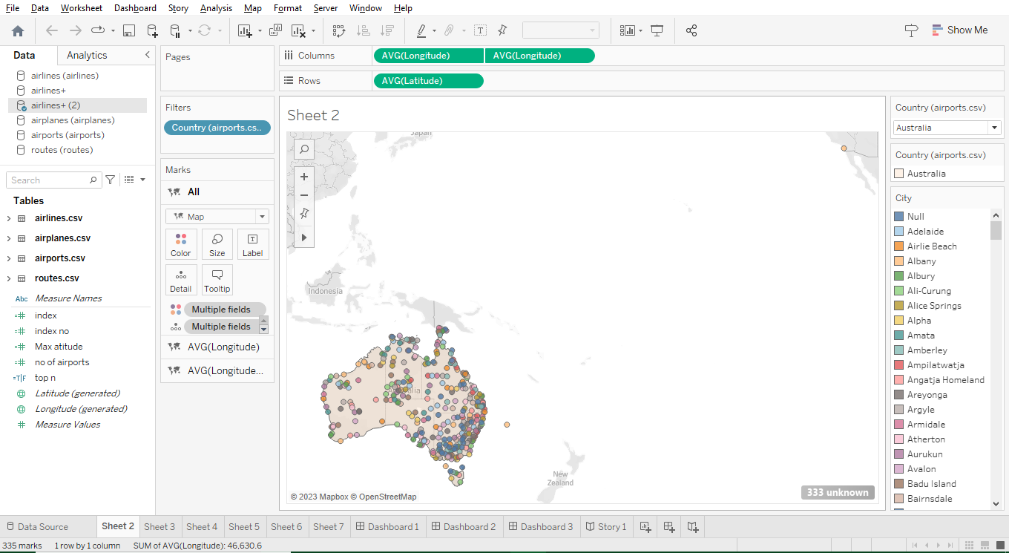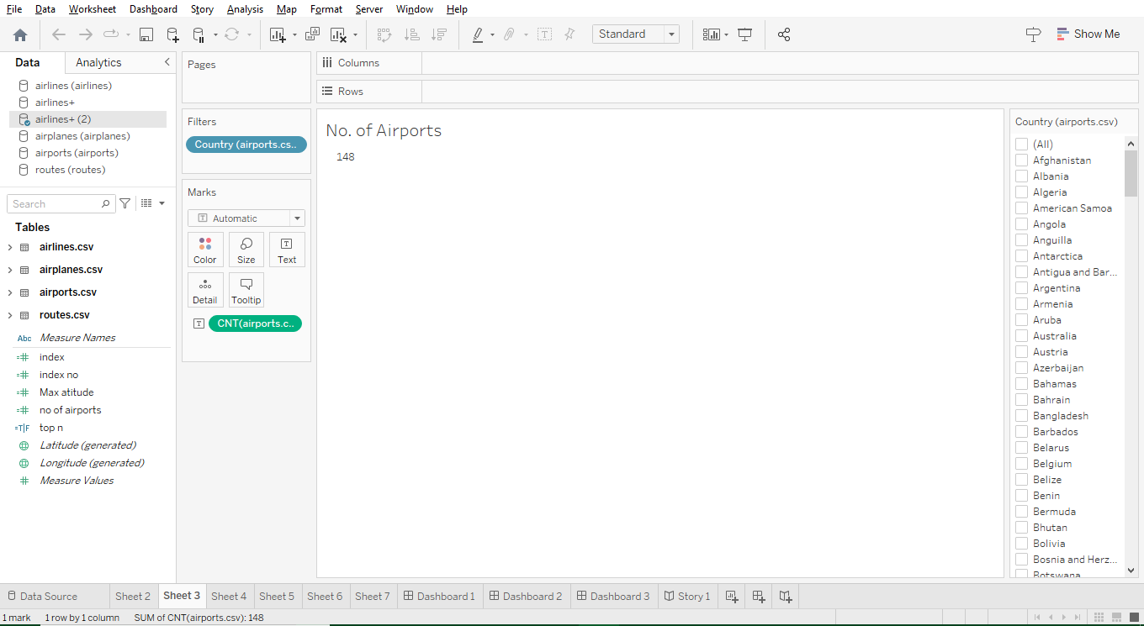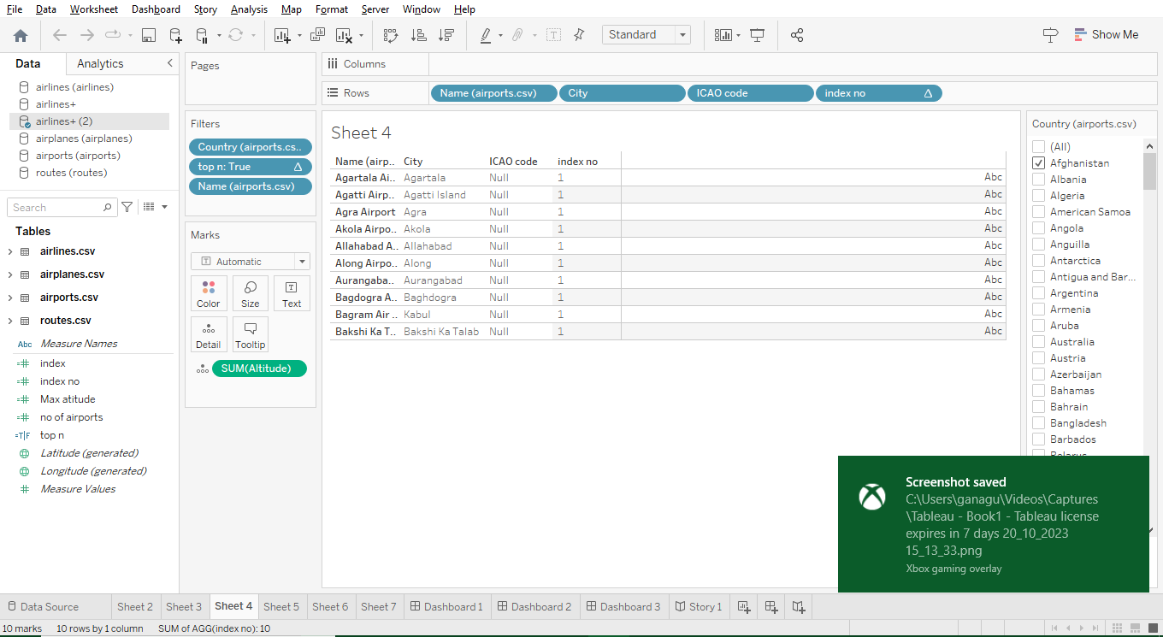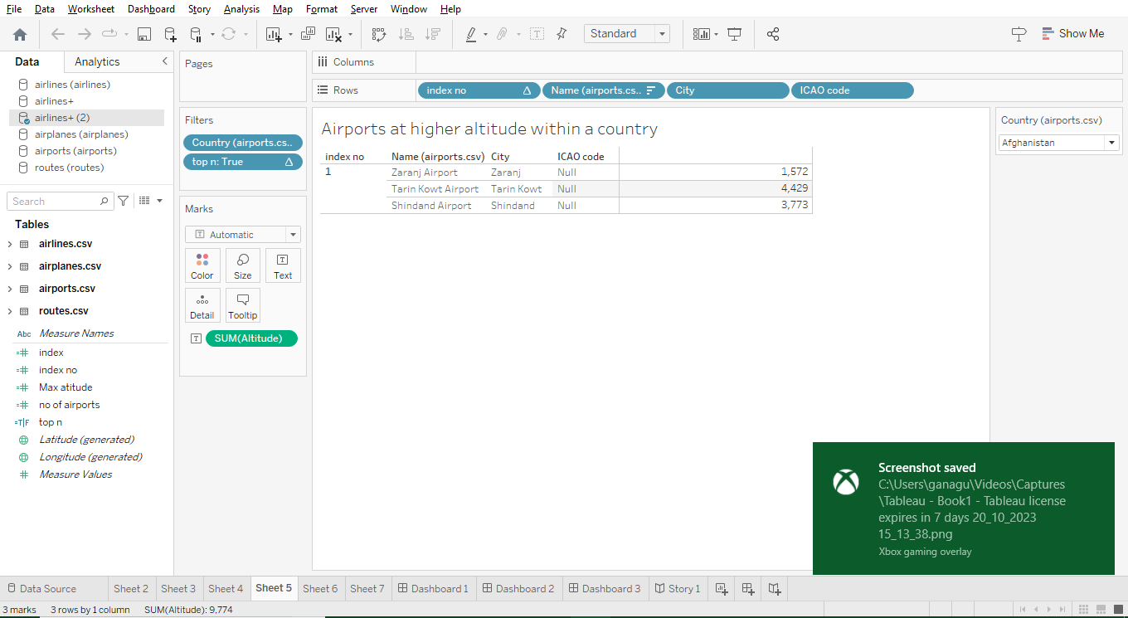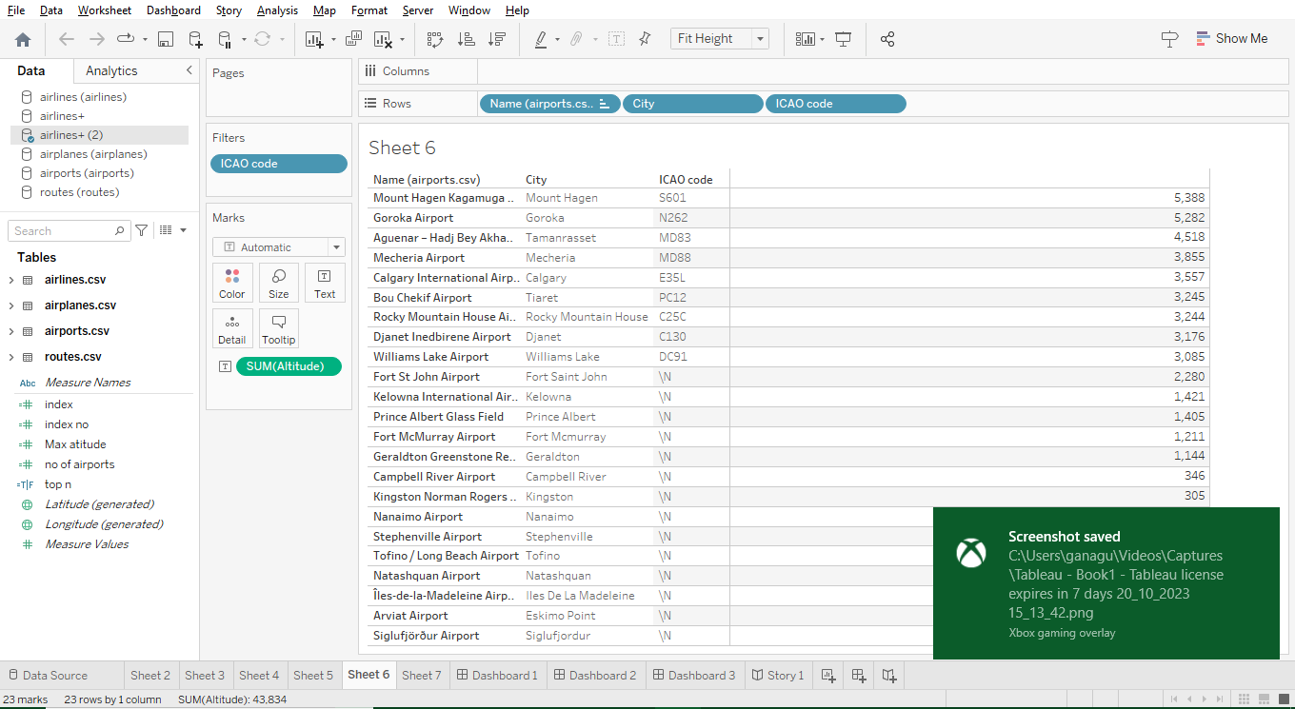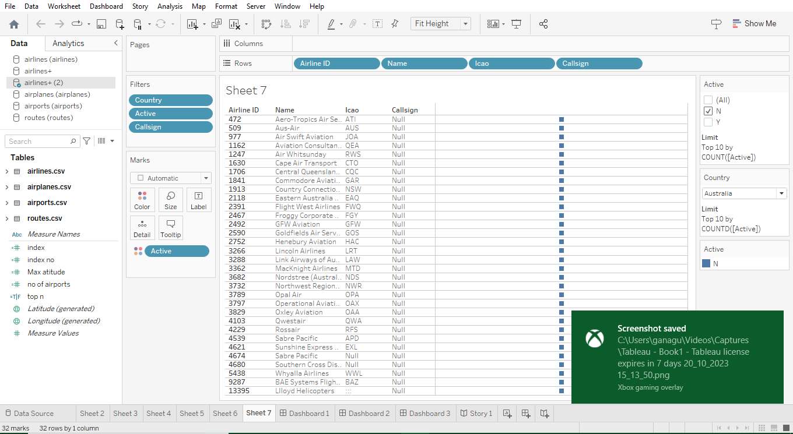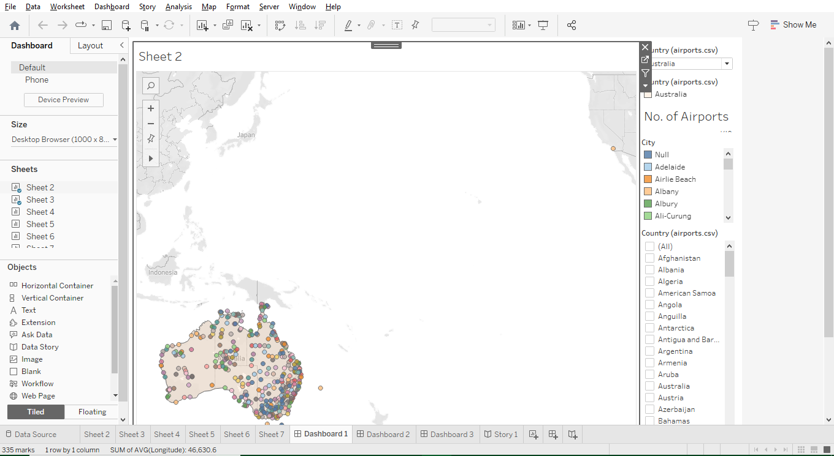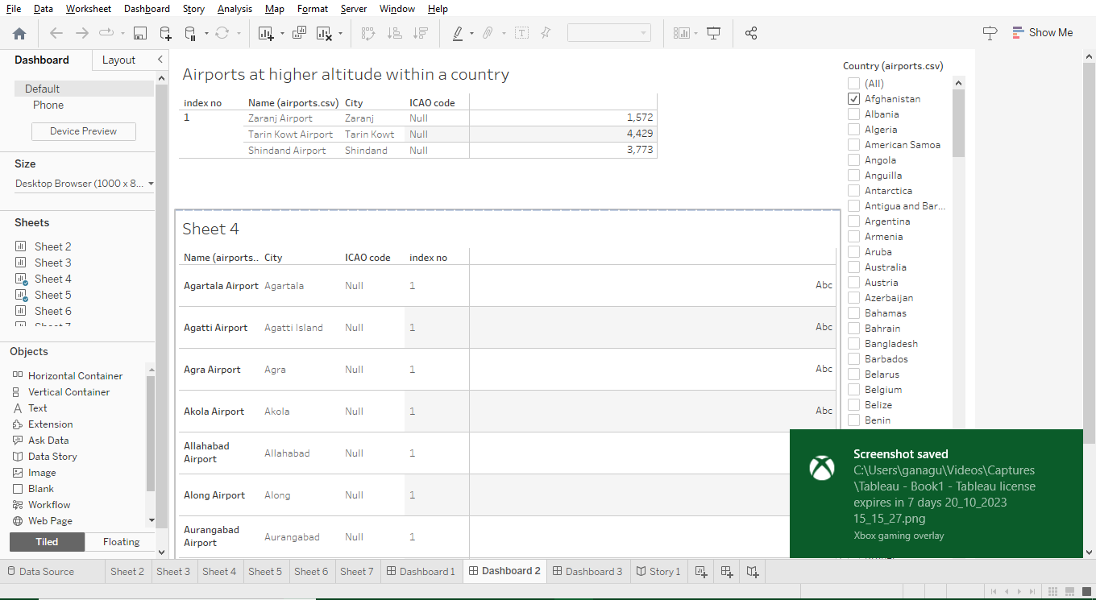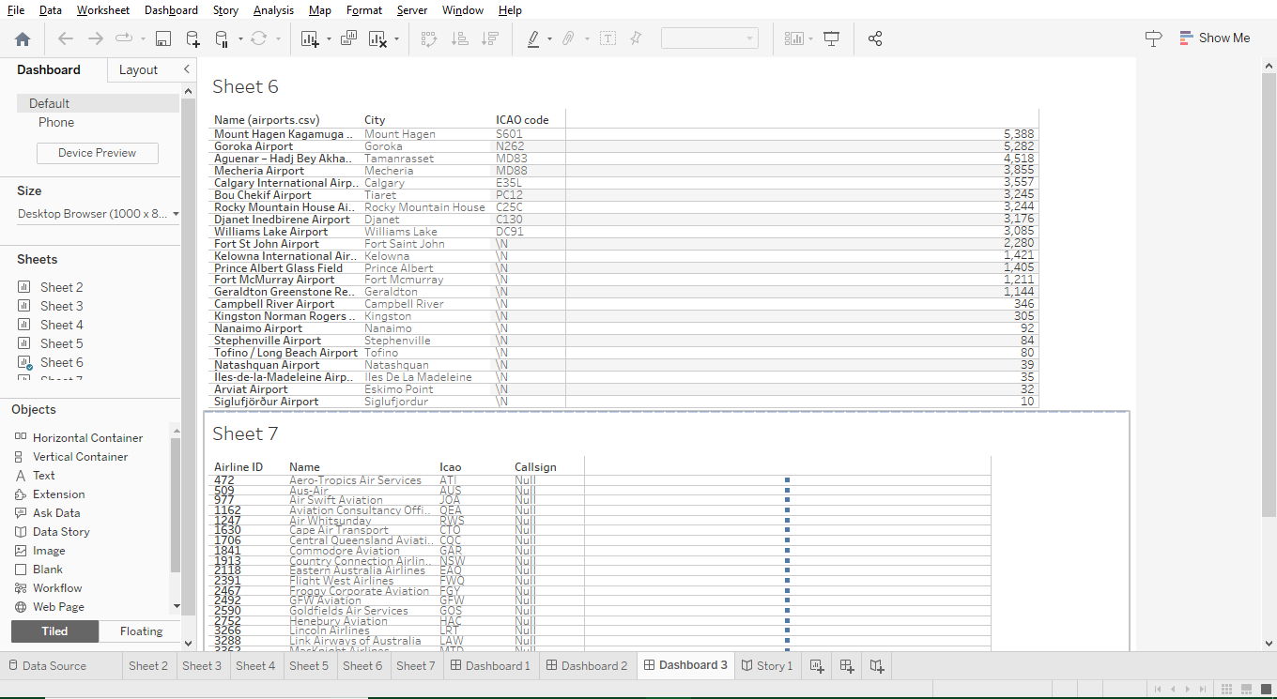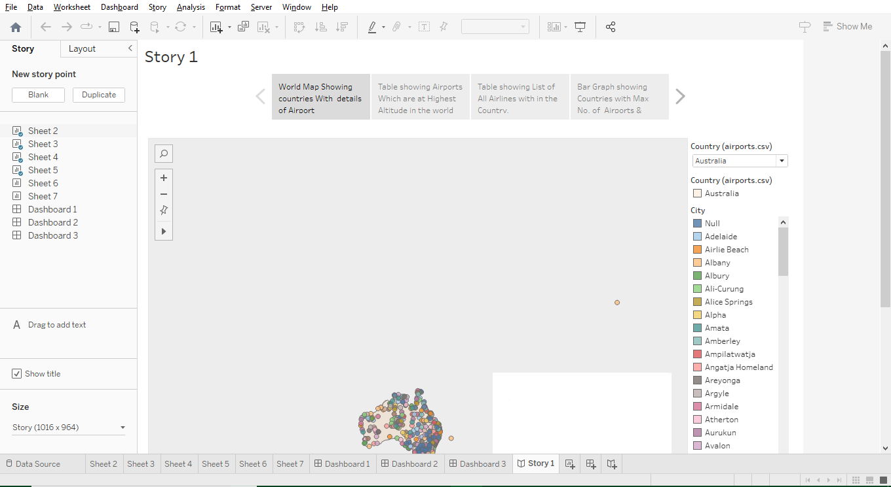

4.Advantages & Disadvantages

**Advantages**:

1. **Data-Driven Decision-Making**: Tableau provides the tools to transform vast amounts of data into actionable insights, enabling data-driven decision-making within the aviation industry.
2. **Comprehensive Visualization**: Tableau's visualizations make complex data more accessible and understandable, aiding in the interpretation and communication of data across various stakeholders.
3. **Operational Efficiency**: Airlines, airports, and regulatory authorities can optimize operations, leading to reduced costs, improved resource allocation, and better service quality.
4. **Safety Enhancements**: By monitoring safety metrics and identifying potential risks, Tableau can contribute to proactive safety measures and a safer aviation network.
5. **Environmental Sustainability**: Insights gained from Tableau can support environmental sustainability efforts, such as optimizing flight routes for fuel efficiency and reducing emissions.
6. **Industry Trends**: The platform helps track industry trends and emerging patterns, enabling faster adaptation to market dynamics and consumer preferences.
7. **Innovation**: Data insights can inspire innovation within the aviation sector, leading to new technologies and operational approaches that enhance services and experiences.
8. **Economic Impact**: Improved efficiency and safety can lead to economic growth, job creation, and enhanced global connectivity.

**Disadvantages**:

1. **Data Complexity**: Managing and processing large volumes of data can be complex and resource-intensive, requiring robust infrastructure and skilled personnel.
2. **Initial Implementation Costs**: The setup and implementation of Tableau and associated data infrastructure can be costly, especially for smaller aviation stakeholders.
3. **Data Privacy and Security**: Handling sensitive data in aviation requires stringent privacy and security measures to protect against potential breaches or misuse.
4. **Resistance to Change**: Stakeholders may resist adopting data-driven approaches, and there could be challenges in convincing them to embrace new methods.
5. **Technical Expertise**: Using Tableau effectively requires a degree of technical expertise, which may not be readily available within all aviation organizations.
6. **Continuous Maintenance**: Data analytics tools like Tableau require ongoing maintenance and updates to remain effective, which can be resource-intensive.
7. **Integration Challenges**: Integrating Tableau with existing systems and processes may be challenging, potentially leading to compatibility issues.
8. **Limited Predictive Power**: While Tableau provides insights from historical data, it may have limitations in predicting future events or trends accurately.

5.Applications

1. **Operational Analytics**: Airlines and airports can use Tableau to gain insights into their day-to-day operations. This includes monitoring flight delays, on-time performance, baggage handling efficiency, and gate allocation to streamline operations and improve the overall passenger experience.
2. **Route Optimization**: Airlines can analyze historical data on routes and passenger demand to optimize their flight schedules and routes. This can lead to cost savings, fuel efficiency, and better service coverage.
3. **Safety Management**: Tableau can be used to monitor safety metrics, incident reports, and maintenance data. Airlines and aviation authorities can identify trends and patterns to improve safety measures and reduce the likelihood of accidents.
4. **Passenger Experience**: Airports can use Tableau to analyze passenger flows, waiting times, and security screening efficiency. Insights can help airports streamline processes and enhance the overall passenger experience.
5. **Environmental Impact**: Airlines can assess and reduce their environmental impact by analyzing data related to fuel consumption, emissions, and eco-friendly practices. This supports sustainability goals and helps meet regulatory requirements.
6. **Capacity Planning**: Airlines and airports can use Tableau to analyze capacity utilization, runway and gate availability, and passenger flow to optimize resource allocation and reduce congestion.
7. **Pricing Strategies**: Airlines can use data insights to refine their pricing strategies based on demand, historical booking data, and market trends.
8. **Crew Management**: Airlines can optimize crew scheduling, fatigue management, and training programs using data-driven insights to enhance safety and efficiency.
9. **Cargo Logistics**: Air cargo companies can utilize Tableau to manage cargo logistics, optimize routes, and track shipments, improving the efficiency and accuracy of cargo services.
10. **Regulatory Compliance**: Aviation authorities can monitor regulatory compliance by tracking data on safety audits, inspections, and compliance with aviation standards.
11. **Crisis Management**: During emergencies or crisis situations, Tableau can be used to analyze real-time data, such as weather conditions and flight disruptions, to make informed decisions and mitigate the impact on operations.
12. **Aircraft Maintenance**: Airlines can optimize aircraft maintenance schedules and predict component failures by analyzing maintenance data, potentially reducing downtime and maintenance costs.
13. **Market Research**: Aviation businesses can use Tableau to conduct market research by analyzing passenger preferences, travel patterns, and customer feedback to better cater to their target audiences.
14. **Performance Benchmarking**: Airlines and airports can compare their performance metrics with industry benchmarks to identify areas where they may need to improve.
15. **Financial Analysis**: Analyzing financial data can help airlines and airports manage budgets, monitor revenue streams, and assess the profitability of different routes and services.

6.Conclusion

The advantages of using Tableau in this context are significant. From operational analytics and route optimization to safety management and environmental impact reduction, Tableau offers a versatile set of tools that cater to the diverse needs of airlines, airports, regulatory bodies, and passengers. Moreover, it supports critical objectives such as safety enhancement, environmental sustainability, and improved passenger experiences.

However, challenges and considerations should not be overlooked. These include data complexity, initial implementation costs, and the need for robust data security and privacy measures. Furthermore, the success of Tableau's application in aviation hinges on the willingness of stakeholders to embrace data-driven practices and adapt to changes.

Overall, by leveraging Tableau to unlock insights into the global air transportation network, the aviation industry can enhance its operational efficiency, safety standards, sustainability practices, and customer experiences. This not only benefits the industry itself but also contributes to global economic growth, improved global connectivity, and a more sustainable and safer means of transporting people and goods across the world. In a world that is increasingly reliant on air transportation, Tableau becomes a valuable ally in optimizing and revolutionizing this vital network.

7.Futurre scope

1. **Advanced Predictive Analytics**: As data collection and analytical techniques continue to evolve, predictive analytics will become more sophisticated. This will enable the industry to anticipate potential issues, such as weather disruptions or equipment failures, and take proactive measures to mitigate them.
2. **Real-Time Data Analysis**: With the increasing availability of real-time data, Tableau can be used to monitor and analyze live data streams, enabling rapid responses to changing conditions and improving operational efficiency.
3. **Artificial Intelligence Integration**: Integrating AI with Tableau can lead to automated insights generation, anomaly detection, and the development of intelligent recommendation systems, further enhancing decision-making and efficiency.
4. **Personalized Passenger Services**: Airlines can leverage data insights to provide personalized services to passengers, such as tailored in-flight experiences, seat selection, and special offers, enhancing customer loyalty.
5. **Environmental Impact Reduction**: The aviation industry will continue to focus on reducing its environmental footprint. Tableau can play a crucial role in tracking and optimizing sustainability efforts, such as fuel-efficient routing and aircraft design.
6. **Supply Chain Optimization**: Air cargo companies can use data analytics tools to optimize the entire supply chain, from tracking cargo movements to warehouse management, leading to more efficient and cost-effective operations.
7. **Blockchain Integration**: Integrating blockchain technology with Tableau can improve data security and transparency, making it easier to track and verify critical data points in the air transportation network.
8. **Regulatory Compliance Monitoring**: The aviation industry faces ever-evolving regulations and standards. Tableau can assist stakeholders in continuously monitoring and adapting to compliance requirements, ensuring safe and secure operations.
9. **Space-Based Analytics**: With the growing number of satellites and space-based data sources, space analytics combined with Tableau can provide insights into flight routes, weather patterns, and airspace management, improving safety and efficiency.
10. **Smart Airports**: Airports of the future can use data analytics to become "smart" by optimizing passenger flows, reducing congestion, and improving security processes, resulting in a seamless and pleasant passenger experience.
11. **Dynamic Pricing Strategies**: Airlines can further refine pricing strategies by incorporating real-time data into their pricing algorithms, enabling them to respond quickly to market fluctuations and passenger demand.
12. **Multi-Modal Transportation Integration**: Integration with other modes of transportation, such as high-speed trains and ground transportation, can create a seamless, multi-modal travel experience, with data insights aiding in coordination.
13. **Public Health and Safety**: In the wake of global health crises, data analytics tools like Tableau can assist in monitoring passenger health and safety, ensuring adherence to health protocols, and facilitating contact tracing when necessary.
14. **Drone and Unmanned Aerial Vehicle (UAV) Integration**: As drone and UAV usage increases, data analytics can help manage airspace and integrate these vehicles safely into the existing air transportation network.
15. **Global Connectivity**: Data insights can be used to enhance global connectivity by optimizing international routes and improving the efficiency of cross-border air transportation.